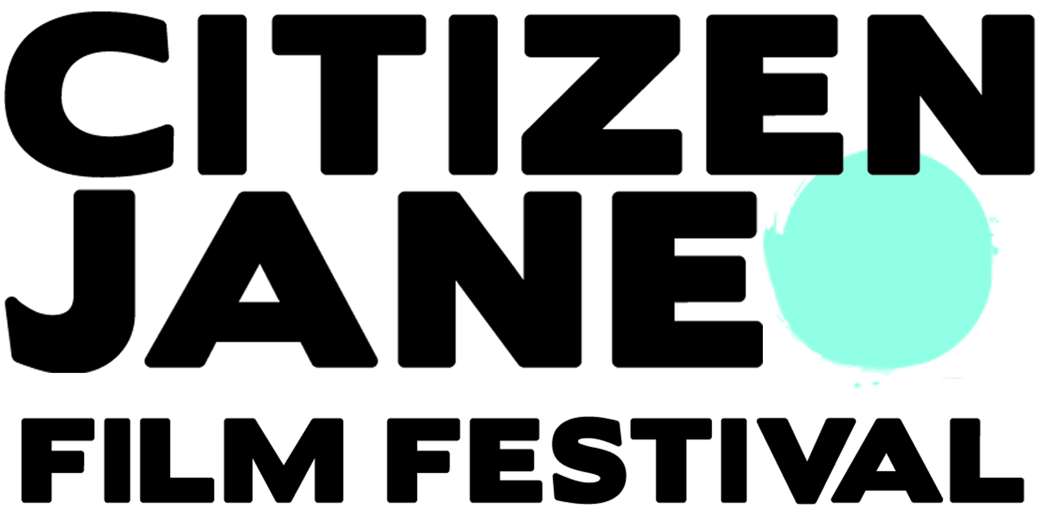
FOR IMMEDIATE RELEASE

FOR MORE INFORMATION, CONTACT:
Paula Elias, Festival Director 573-489-6147
paula@citizenjanefilm.org

8th ANNUAL CITIZEN JANE FILM FESTIVAL RETURNS OCTOBER 22-25, 2015

COLUMBIA, Mo.— The Citizen Jane Film Festival returns to downtown Columbia and the Stephens College campus for its eighth year, kicking off with the CJ Summit on Oct. 22.
Presented by the Citizen Jane Institute at Stephens College, the festival is one of the only film festivals in the nation that headlines the work of female filmmakers. Films will be screened throughout the weekend of Oct. 23-25 at the Missouri Theater, Stephens College and The Blue Note.
The CJ Summit returns to the festival for the third year from 5:30 pm to 7:00 pm on Oct. 22 at Stephens College Historic Senior Hall. The event, which is free and open to the public, allows filmmakers and industry experts to discuss the challenges facing women in film. This year, the summit will be broadcast live on shedoespodcast.com.
CJFF’s 2015 opening night film will be FRAME BY FRAME directed and produced by University of Missouri alumna Mo Scarpelli and Alexandria Bombach.
“This beautifully shot, award-winning documentary is told by four Afghan photojournalists facing the realities of building a free press in a country left to stand on its own after decades of war and an oppressive Taliban regime,” said Paula Elias, Festival Director. “No wonder Hollywood Reporter dubbed it a ‘work of profound immediacy, in sync with the photographers’ commitment and hope.’”
A full line-up of CJFF films and festival events will be released Sept. 18 at citizenjanefilm.org.
Elias said organizers are also excited to host visiting filmmakers for virtually every documentary and fiction feature that will be screened, including many of the short films. This will give CJ audiences the rare opportunity to connect with the filmmakers and for filmmakers to network.
Passes are now available. An “Insane Jane” pass is $100 and includes one ticket to all films, parties and special events, including the private filmmaker brunch at Historic Senior Hall on the Stephens campus. A “Plain Jane” pass is $60 and includes the opportunity to reserve one ticket to all films pending availability.
Elias encourages area residents to check out the festival, even if they’ve not attended in the past.
“We fly filmmakers from around the world into Columbia for the weekend, and festival goers get the chance to connect with them and each other in a really intimate environment,” Elias said. “We have grown by about 50 percent every year, but we’re committed to holding on to the intimate feeling of Citizen Jane.”
###

